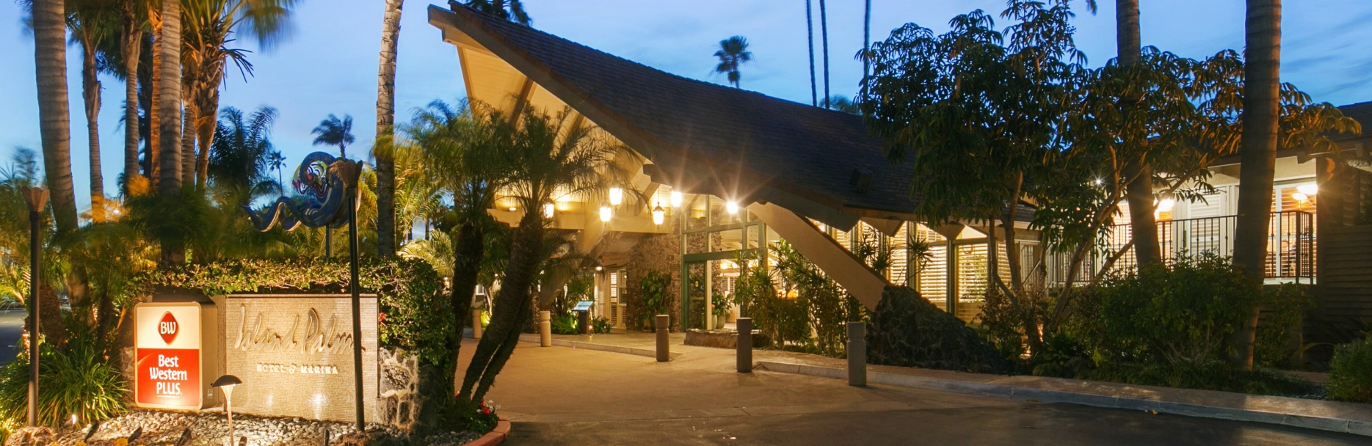
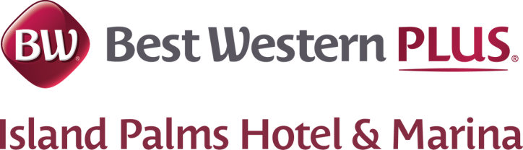

2051 Shelter Island Drive, San Diego, CA 92106 P: 619.222.0561 F: 619.222.9760

Special Guest Room Rates for

San Diego GCSA Holiday Party Block

Dates: December 2-4, 2022
Rate/Discount: $119 per night (standard rooms)

To make reservations, please call the Best Western PLUS Island Palms Reservations Department at 800-551-5573. Please mention the San Diego GCSA Holiday party at the time of making reservations to receive your special rate. An advance deposit or credit card guarantee for the first night’s room and tax is required at the time the reservation is made. Rates do not include 10.5% tax, 2.0% Tourism Marketing Assessment and 0.195% California Tourism fee.
Parking is $15 per night.
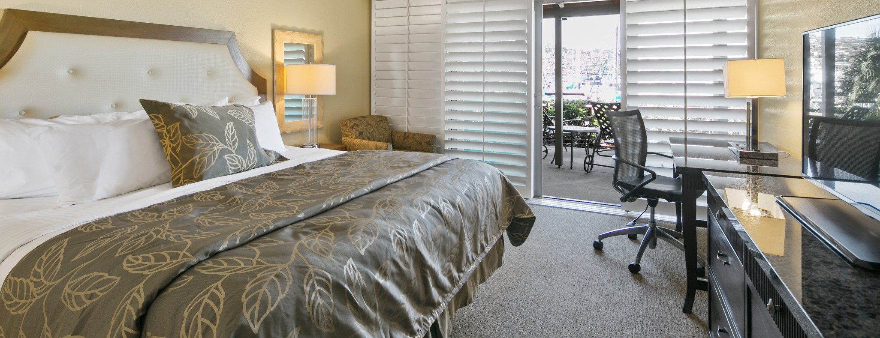
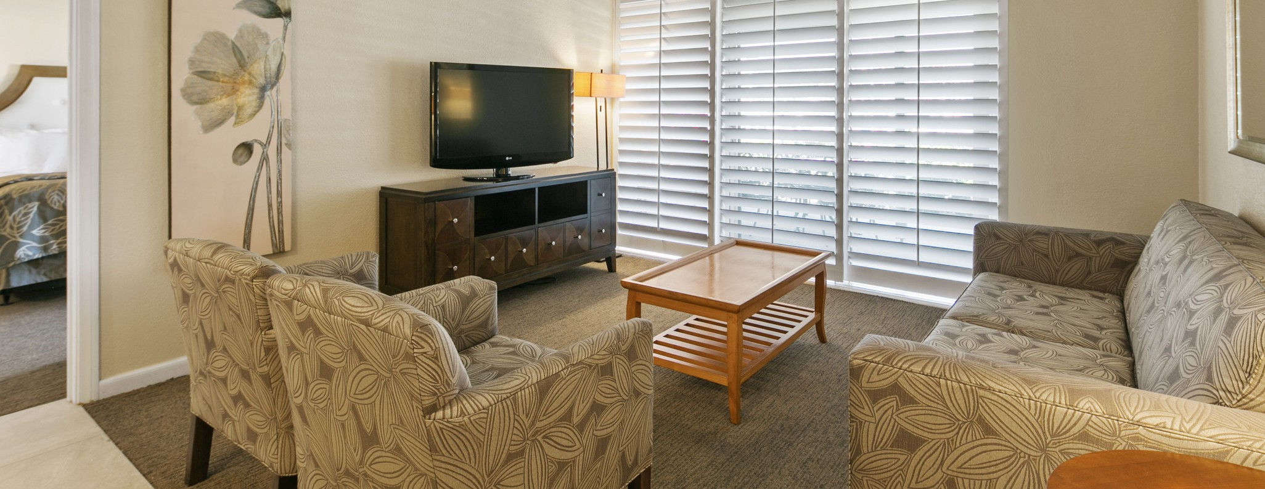
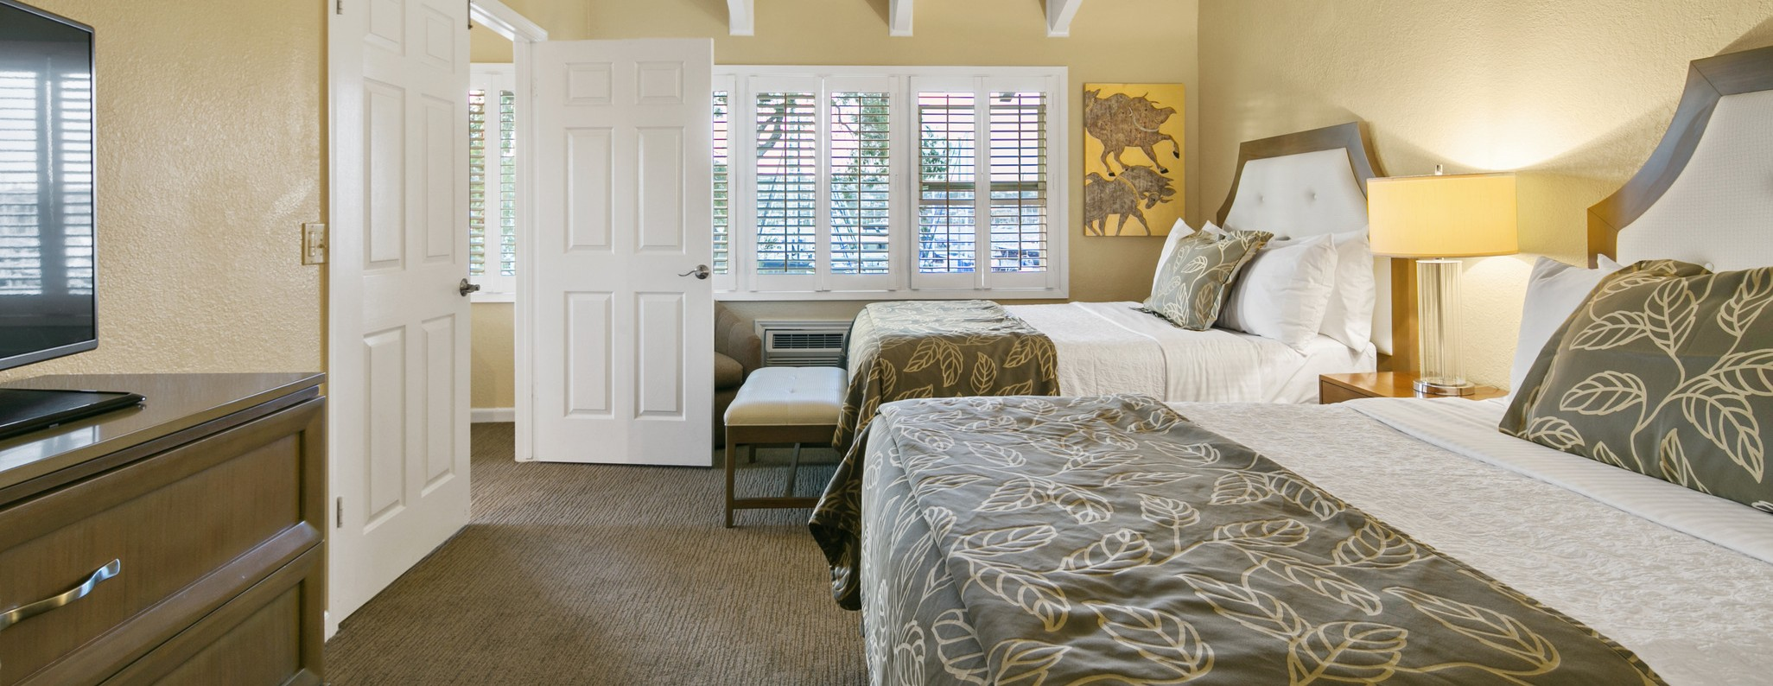
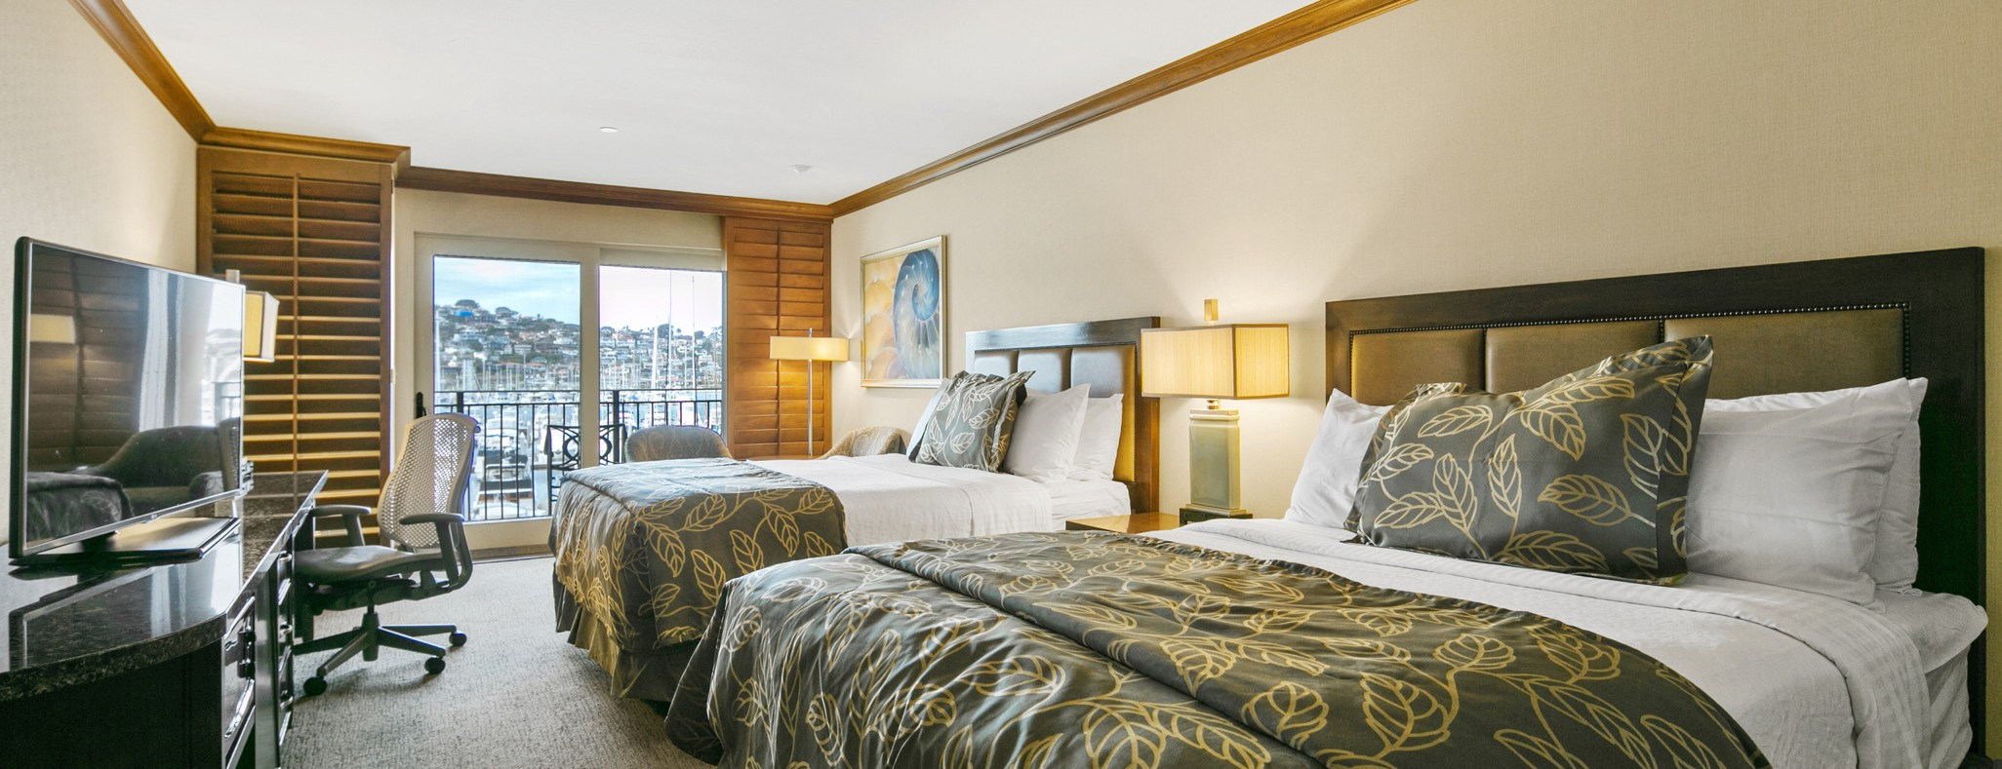
Special discounted rates offered until the hotel reaches 80% occupancy for dates of travel. Rates are subject to availability and occupancy restrictions. *Discount is taken from the hotel's "Best Available Rate" and cannot be combined with any other offer, discount, special or promotional rate. Please note that check in time is 4:00 PM and check out time is 12:00 PM. Due to seasonal arrival and departure patterns, it is not uncommon for guest room check in to occur at 4:00 PM. Early check ins are a request only and are not guaranteed. Hotel rooms and specific room numbers are not guaranteed and are subject to change.

